NYSSLS Daily Lesson Plan
Instructional Unit:  Weather and Climate –  Air masses, Fronts and Weather  LESSON - The Water Cycle, Phase Changes, factors effecting evapotranspiration and types of precipitation |  |  |  |  |  | Period(s) of Unit:  6 periods |  | Date:
Materials/Resources/Links:  Natural water cycle game | South East Water Education (educationsoutheastwater.com.au)  State of Water – Javalab  Factors affecting Rate of Evaporation (youtube.com)  Where did Dew come from? - Javalab  Hydrologic Cycle STEM Case : Lesson Info : ExploreLearning |  |  |  |  |  |  |  | Course:  Earth and Space Science
Special Notes for Lesson:

ANCHORING PHENOMINON: - Did you ever wonder why different forms of precipitation falls from the sky? Where does he water go? What is the driving force of weather?

Standards:
Science and Engineering Practices  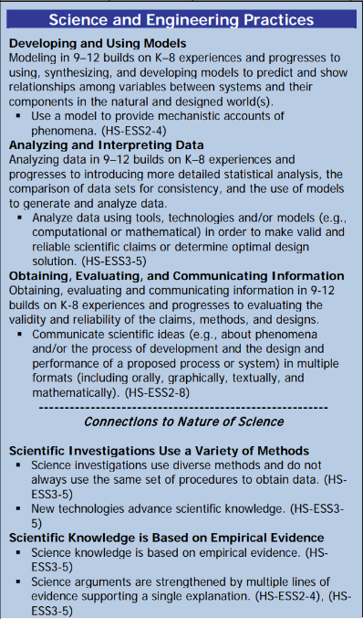 |  |  | Disciplinary Core Idea(s)  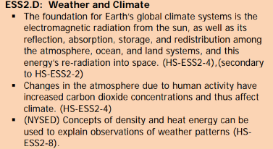 |  |  |  | Cross Cutting Concepts  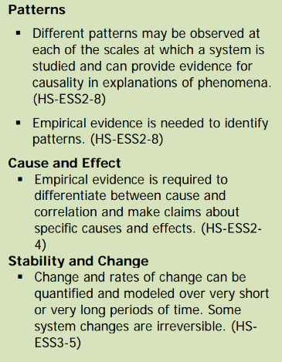
Performance Level
NYS Level 5 | NYS Level 4 |  |  | NYS Level 3 | NYS Level 2 |  |  | NYS Level 1
Collect and analyze global and regional weather data using tools, technologies, and /or models to communicate in multiple formats how the movement and interactions of airmasses result in changes in weather conditions | Evaluate data and communicate information to explain how the movement and interactions of air masses result in changes in weather condition |  |  | Evaluate data and communicate information to identify patterns of movement and/or the resulting changes in weather conditions. | Use data to identify the patterns of movement or the interactions of air masses and the resulting change in weather conditions  or to identify factors that drive the movement of air masses or from given weather conditions, identify evidence from maps that support these conditions. |  |  | Use data and/or patterns of movement and interactions of air masses to identify the resulting changes in weather conditions or identify one factor that drives the movement of air masses or from those provided, use evidence from maps to account for weather conditions or given weather conditions, identify evidence found on maps that account for one of these conditions.
Clarification Statement  Examples of evidence sources could include station models, surface weather maps, satellite images, radar and accepted forecast models. Emphasis should focus on communicating how the uneven heating of the Earth’s surface at frontal boundaries and resulting weather phenomena. |  |  |  |  | Assessment Boundary  Analysis is limited to surface weather maps and general weather patterns associated with High and Low pressure systems
Connection to Anchoring Phenomenon:
Phase changes driven by the sun are essential to understanding the water cycle. Understanding of the water cycle is essential to the understanding of weather phenomenon caused by frontal boundaries and air masses .

Essential Question(s):
What is a cycle?

In your own words explain what the water cycle is.

What are the different states of matter and the different phase changes.

For each phase change describe weather require the addition or subtraction of energy from the water.

Where does the energy for the water cycle come from?

What does precipitate mean?

What are the different types of precipitation and how do they form?

Instructional Strategies & Learning Tasks: Engage, Explore, Explain, Elaborate, Evaluate
Engage: images, video clip or data… |  | Students will play the water cycle game and design their own water cycle. The class will discuss weather they think the cycle is complete. The students will also come up with ideas as to what is the driving force of the water cycle.
Explore: Students investigate, experiment, hands-on activity…. |  | Students will investigate phases of matter and phase changes using online mini labs. They will also investigate the factors that effect evapotranspiration by watching a video.
Explain: Students share their observations and evidence to explain their understanding…possible whole group/class discussion… |  | Students will design their own water cycle and investigate the phases of matter and phase changes
Elaborate: Students apply the science concepts they’ve just learned… |  | Students will apply their knowledge of the phases of matter and phase changes to the water cycle they designed in the beginning of class. The class will then evaluate if the cycle is complete.  Students will then apply their knowledge of the water cycle to help a community in India during flooding by completing a STEM case on the hydrologic cycle.
Evaluate (Formative Assessment): Student learning is evaluated. |  | Students will be evaluated by teacher questions during the lesson as well as a formal test or quiz will be given

Copy and paste student worksheets below:

